# Expression of Interest: Official Application

**Background**

Rural Resilience Activity (RRA) is a Feed the Future initiative funded by the United States Agency for International Development (USAID), implemented by Mercy Corps in partnership with Save the Children International (SCI) and International Fertilizer Development Center (IFDC). The goal of the Rural Resilience Activity is to ‘facilitate and protect economic recovery and growth in vulnerable, conflict-affected areas and sustainably move people out of chronic vulnerability and poverty via expanded opportunities’. This goal will be achieved through the following four major components. The Activity seeks to increase incomes, improve the livelihood and resilience of households through market-led growth in 4 States (Adamawa, Borno, Gombe and Yobe states) in North Eastern Nigeria.

Layered on the principles of broadened and inclusive growth through agricultural competitiveness; the Activity objectives of a) inclusive and sustainable agriculture-led economic growth; b) strengthened resilience among people and systems; and c) a well-nourished population, especially women and children, thereby contributing to sustainable reductions in global hunger, malnutrition and poverty.

The Activity seeks Expression of Interest (EoI) from Local Service Providers (LSPs) with market-driven business support service solutions to implement innovative business models targeting smallholder farmers, youth, women and micro-enterprises who have been affected by the protracted conflicts in North Eastern Nigeria.

**Specific objectives:**

* Lead and provide business and technical training and advisory services to producer/marketing collectives and savings groups, using a standardized business and group management training curriculum.
* Link producer/marketing collectives and savings groups to formal financial service providers to access services such as savings, credit, insurance etc.
* Link producer/marketing collectives and savings groups involved in both agricultural and non-agricultural economic activities to input markets.
* Link producer/marketing collectives and savings groups involved in both agricultural and non-agricultural economic activities to input higher-value output markets.

**Criteria:**

* The Local Service Provider (LSP) must be a registered entity with a recognized regulatory body.
* Must have experience in providing training and advisory services to farmer groups or savings groups.
* Must be operational in any of the 4 states of implementation or willing to expand its services into Borno, Adamawa, Yobe and Gombe States

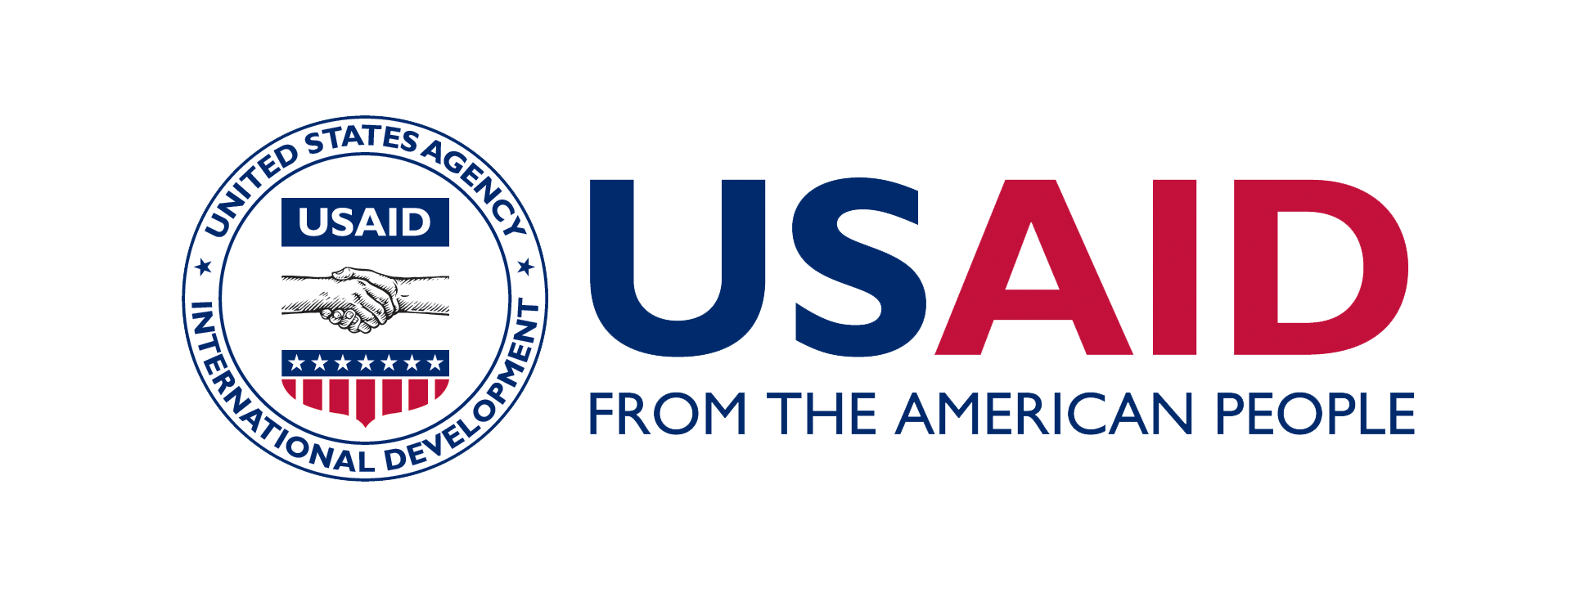



|  |  |  |
| --- | --- | --- |
| Company/Organization Name |  | |
| Point of Contact  *\*Please list one individual to receive all communications from Rural Resilience Activity regarding this EOI.* | First Name | Last Name |
| Company/Organization Address | Point of Contact Email | Point of Contact Phone Number |
| How did you learn about this opportunity? |  | |
| Your company/organization is a:  *\*Please check only one box.* | __ For-profit __ University  __ Non-profit __ Government entity  __ Research institute __ Other (please specify) | |
|  | | |
| States in Nigeria or Internationally, in which your company provides or has provided business capacity building services. |  | |
| Are you willing to have the name of your organization and project or technology featured on the Mercy Corps website and other digital media channels used by the Rural Resilience Activity?  ___ Yes ___No  *\*Rural Resilience Activity compiles and shares general information on the EOIs, including information on types of organizations, business capacity building services provided, and geographies represented.* | | |
|  | | |
| Has your organization been in partnership with or received funding from any US government or other donor agency in the past? If so, please describe. | | |

|  |  |  |
| --- | --- | --- |
| Expression of Interest: Official Application *Instructions: Please provide an answer to each question in the box provided. Failing to answer all questions will result in automatic disqualification.*  **Background and Organizational Qualifications**  Tell us about your company. How long have you been in business? Where do you have offices and in which locations do you provide services? What type and size of businesses have you supported through business advisory services? When and where did this support take place?   |  | | --- | |  |   **Q1. Technical Assistance**  What types of technical assistance have you provided or can you provide to youth or women owned, managed, or operated commercial agribusinesses in Northeast Nigeria?  Please list the specific services that your company is qualified to provide along with a brief description of each.   |  | | --- | |  | |
| **Q2. Organizational Capacity**  Describe your organization’s management structure, including the names and qualifications of the key personnel who would provide this technical assistance.   |  | | --- | |  | |
|  |
| **Q3. References**  Please provide three references who can speak to the business capacity building services you have provided to women owned, managed, or operated agribusinesses.   |  | | --- | |  | |

**EXPRESSION OF INTEREST**

To apply: Interested individuals should submit their expression of interest on or before 15th November 2021 to the email address below: [ng-gmbprocurement@mercycorps.org](mailto:ng-gmbprocurement@mercycorps.org)

.